________________, prions and viroids are not composed of cells
A. Viruses
B. Plants
C. Animals
D. Human
ANSWER: A
The branch that deals with the study of viruses is known as?
A. Entomology
B. Bacteriology
C. Virology
D. Epidemiology
ANSWER: C
A __________is a submicroscopic non-cellular infectious agent that replicates only inside the living cells of an organism
A. Virus
B. Bacteria
C. Protozoa
D. Fungi
ANSWER: A
Which of the following show the characteristics of living and non-living?
A. Virus
B. Bacteria
C. Protozoa
D. Fungi
ANSWER: A
Which of the following is the living characteristic of viruses?
A. They lack cellular structure
B. They do not have metabolic activity of their own
C. They do not respire
D. They have their own genetic material in the form of either DNA or RNA
ANSWER: D
Which of the following is the non-living characteristic of viruses?
A. They have their own genetic material in the form of either DNA or RNA
B. They reproduce using host metabolic machinery
C. They are destroyed by ultraviolet rays
D. They lack cellular structure
ANSWER: D
The living characteristic of the virus include:
A. They have their own genetic material in the form of either DNA or RNA
B. They reproduce using host metabolic machinery
C. They enter the cells of the living organism and cause disease
D. All of these
ANSWER: D
The non-living characteristic of the virus include:
A. They lack cellular structure
B. They do not have metabolic activity of their own
C. They do not respire
D. All of these
ANSWER: D
The word is from the Latin neuter vīrus referring to:
A. Bad
B. Beside
C. Poison
D. Coat
ANSWER: C
Which was the first virus to be successfully crystallized?
A. TMV
B. Smallpox
C. Poliovirus
D. Adenovirus
ANSWER: A

A complete virus particle, known as a:
A. Prion
B. Lysogeny
C. Virion
D. Bacteriophage
ANSWER: C
The protein coat that encloses viral sets of genes is called:
A. Vector
B. Capsid
C. Plasmid
D. Genome
ANSWER: B
A virus is made up of:
A. Protein coat and nucleic acid
B. Protein coat and mitochondria
C. Nucleic acid and cell membrane
D. Nucleic acid, cell wall, and cell membrane
ANSWER: A
Who led the experiments that proved that yellow fever is transmitted by the bite of a mosquito?
A. Jan Ingenhousz
B. Walther Fleming
C. Walter Reed
D. Waldeyer
ANSWER: C
HIV is thought to have originated from:
A. Birds
B. Mosquitos
C. Chimpanzees
D. None of the above
ANSWER: C
In what year did WHO declare that smallpox was completely eradicated?
A. 1990
B. 1980
C. 2001
D. 1995
ANSWER: B
Which was the first virus to be successfully crystallized?
A. TMV
B. Smallpox
C. Poliovirus
D. Adenovirus
ANSWER: A
The branch that deals with the study of viruses is known as?
A. Entomology
B. Bacteriology
C. Virology
D. Epidemiology
ANSWER: C
When were bacteriophages discovered by Twort?
A. 1915
B. 1920
C. 1910
D. 1820
ANSWER: A
When was the bacteriophage phenomena rediscovered by D'Herelle?
A. 1918
B. 1917
C. 1920
D. 1990
ANSWER: B
Which of the following is considered the founder of vaccinology?
A. Beijerinck
B. Edward Jenner
C. Adolf Eduard Mayer
D. Ivanowski
ANSWER: B
Which one is not useful in the treatment of viruses:
A. Acyclovir
B. Twinrix
C. Penicillin
D. Havrix
ANSWER: C
RSV was discovered in __________ by Peyton Rous
A. 1900
B. 1856
C. 1911
D. 1850
ANSWER: C
When was the agent causing AlDs discovered?
A. 1994
B. 1984
C. 1950
D. 1920
ANSWER: B
The word virus is derived from a:
A. Greek word
B. Italian word
C. Latin word
D. Arabic word
ANSWER: C
Venom means:
A. Toxin
B. Toxicant
C. Poison
D. Rancor
ANSWER: C
Viruses were first discovered after the development of a porcelain filter:
A. The Chamberland-Pasteur filter
B. Adolph Meyer
C. Dmitri Ivanowsky
D. Richard
ANSWER: A
Tobacco mosaic disease was thought to be caused by:
A. Virus
B. Bacteria
C. Protozoa
D. Fungi
ANSWER: B
TMV is a:
A. DNA Virus
B. RNA Virus
C. ss DNA or ds DNA
D. Bacteriophage
ANSWER: B
The HIV genome consists of:
A. dsRNA
B. ssRNA
C. ssDNA
D. dsDNA
ANSWER: B

Where does the bacteriophage replicate?
A. Human
B. Animal
C. Bacteria
D. Horse
ANSWER: C

What is the shape of the TMV Virus?
A. Rod
B. Spherical
C. Tadpole
D. Complex
ANSWER: A

What is the capsid (protective coat) of the bacteriophage made up of?
A. DNA
B. RNA
C. Protein
D. Organic acids
ANSWER: C
Which of the following represents the shape of the bacteriophage?
A. Pear
B. Tadpole
C. Spherical
D. Oval
ANSWER: B
A typical bacteriophage consists of:
A. Head
B. Neck
C. Tail
D. All of these
ANSWER: D
Which of the following enzymes is found in bacteriophage?
A. Lysozyme
B. Dehydrogenase
C. Protease
D. Nitrogenase
ANSWER: A
Which of the following is not true for a bacteriophage?
A. A very simple structure
B. Consist either DNA or RNA
C. Bacteriophages are viruses
D. Complex structure that infects bacteria
ANSWER: D
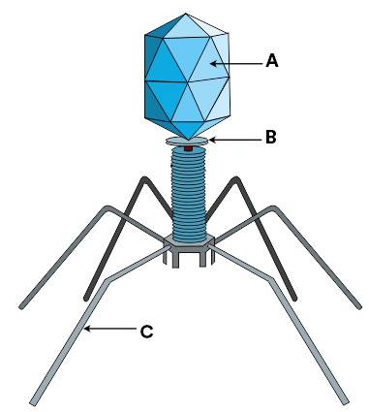
What does A represent in the given diagram?
A. Head
B. Collar
C. Tail fibre
D. DNA
ANSWER: A

What does C represent in the given diagram?
A. Head
B. Collar
C. Tail fibre
D. DNA
ANSWER: C
HIV belongs to which of the following genus member of the virus?
A. Ortho myxovirus
B. Retrovirus
C. Parvovirus
D. Reovirus
ANSWER: B
A HIV virion is largely _________ in shape
A. Pear
B. Tadpole
C. Spherical
D. Oval
ANSWER: C
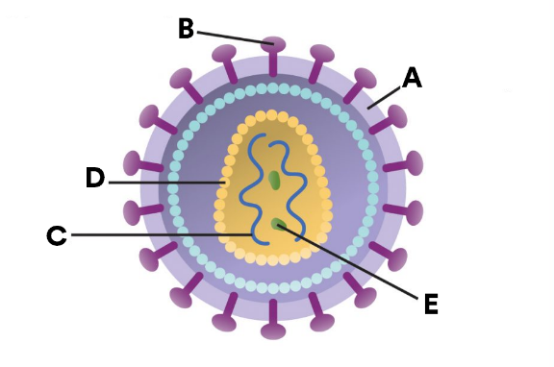
Observe the diagram and identify the structure labeled A:
A. Glycoprotein
B. Viral core (RNA)
C. Viral envelope
D. Capsid
ANSWER: C

What does B represent in the given diagram?
A. Glycoprotein
B. Viral core (RNA)
C. Viral envelope
D. Capsid
ANSWER: A

What does C represent in the given diagram?
A. Glycoprotein
B. Viral core (RNA)
C. Viral envelope
D. Capsid
ANSWER: B

Observe the diagram and identify the structure labeled D:
A. Glycoprotein
B. Viral core (RNA)
C. Viral envelope
D. Capsid
ANSWER: D

Observe the diagram and identify the structure labeled E:
A. Glycoprotein
B. Viral core (RNA)
C. Viral envelope
D. Reverse transcriptase
ANSWER: D

